Tasks
1.
Write a short scenario where a user tries to access a private WiFi network (like at a campus or airport) and describe how each of the three AAA functions—Authentication, Authorization, and Accounting—would apply step by step in this situation.
>
Scenario
A passenger named Alex wants to connect to a private, premium airport WiFi network ("Airport_Premium_Secure") while waiting for a flight.
Step-by-Step AAA Application
- 1. Authentication (Who are you?): Alex selects the WiFi network, and a captive portal web page pops up. Alex is prompted to enter a unique ticket booking reference number (PNR) and last name. The network server checks this database to verify that Alex is an actual passenger with a valid ticket. Once verified, identity is confirmed.
- 2. Authorization (What are you allowed to do?): Once authenticated, the system checks Alex's ticket class. Since Alex holds a Business Class ticket, the network dynamically assigns a specific security profile. This profile authorizes access to high-speed Internet (50 Mbps) and allows streaming services, whereas economy passengers might be restricted to 5 Mbps and browsing only.
- 3. Accounting (What did you do and for how long?): As soon as the session begins, the network logs the exact login time, the device's MAC address, and tracks data consumption. When Alex logs off or the flight departs, the system logs the logout time and total data used (e.g., 2.5 GB transferred over 2 hours). This data is stored for security compliance and network auditing.

2.
Create a table comparing at least two different AAA deployment models (such as centralized vs distributed), listing three advantages and three disadvantages of each for a company like Zomato that handles sensitive user data.
>
Deployment Model | Advantages | Disadvantages
Centralized AAA (Single central server managing all locations/requests) | 1. Easier Data Management: Simple to enforce strict, uniform security and data privacy compliance policies across all regions.  2. Low Overhead: Easier to update, patch, and monitor a single central cluster.  3. Consistent Logs: All sensitive user session data goes to one secure place, simplifying audits. | 1. Single Point of Failure: If the central AAA server goes down, authentication fails globally for all users and delivery partners.  2. Latency Issues: Users physically far away from the central data center may experience slower login times.  3. High Network Dependency: Highly reliant on constant, stable WAN connectivity to the central cloud.
Distributed AAA (Multiple regional servers handling local requests) | 1. High Availability: If the North India server goes down, West and South India operations continue completely unaffected.  2. Low Latency: Regional servers process user authentication locally, resulting in snappy login times.  3. Scalability: Easy to handle massive traffic spikes during peak dinner hours by scaling regional servers independently. | 1. Complex Synchronization: Difficult to sync sensitive user credentials and real-time session logs across multiple databases instantly.  2. Higher Security Attack Surface: Securing multiple decentralized server environments containing sensitive data is much harder.  3. Increased Cost: Higher infrastructure and maintenance costs to run multiple server nodes.

3.
Draw a simple network diagram (can be hand-drawn and photographed) showing how AAA servers are integrated into a typical enterprise network for user access control, labeling where Authentication, Authorization, and Accounting processes happen.
>
Process Labels for Paper Drawing
- Authentication Point: Occurs when the user sends credentials to the NAS, which passes them to the AAA Server to verify identity.
- Authorization Point: Occurs after validation, where the AAA server passes access privileges (e.g., VLAN assignment or ACLs) back to the Switch/NAS.
- Accounting Point: The continuous connection where the NAS streams usage logs and session duration data back to the AAA Server's database.

4.
Pick any app you use daily (Instagram, Paytm, or Flipkart) and write a paragraph explaining how AAA concepts could be applied to secure user logins and actions within that app.<br><br><em><strong>Hint:</strong> Think about what happens when you log in, what features you are allowed to use, and how your actions might be tracked for security or billing.</em>
>
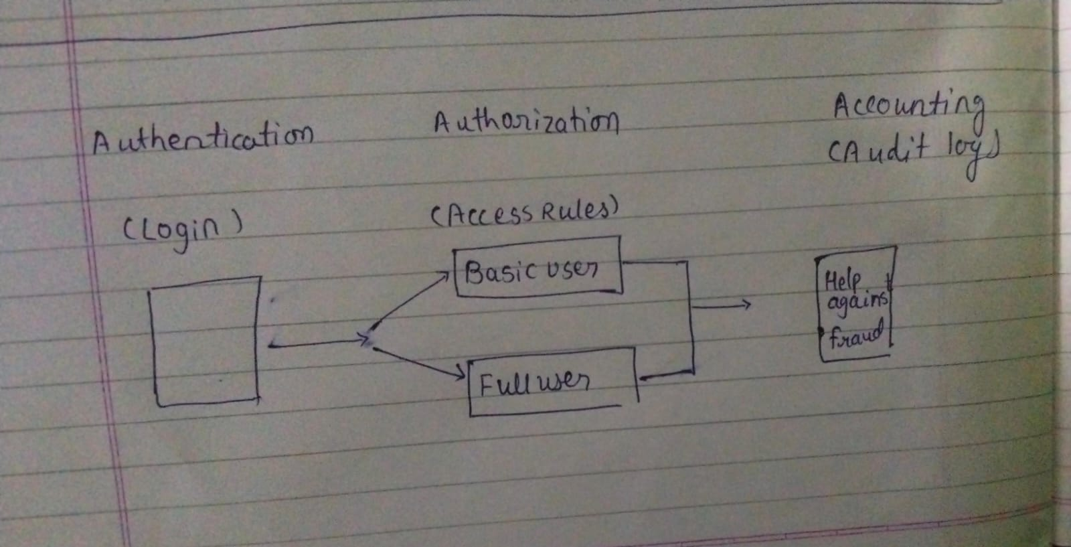
When you log into Paytm, AAA concepts run seamlessly in the background to ensure security and prevent financial fraud:
- Authentication: When you open the app, you must enter a passcode, use fingerprint/FaceID, or receive a 6-digit OTP sent to your registered phone number. This strictly verifies that you are the true owner of the account.
- Authorization: Once inside, your access is governed by permissions. If your account has basic KYC, you are authorized to make limited wallet transfers. If you have full KYC, you are authorized for larger transactions. Furthermore, you cannot view or access another user's linked bank account or transaction history.
- Accounting: Paytm maintains a definitive ledger of every action. Every time you send money, pay a merchant, or receive a refund, it records the transaction ID, amount, timestamp, and location. This keeps your passbook updated, prevents fraud, and handles disputes or billing questions.

5.
Use ChatGPT or any AI tool to generate a sample AAA policy for a college WiFi network that restricts access to students only, allows certain websites, and logs all access attempts. Paste the generated policy and briefly explain how each AAA function is addressed.
>
Network Policy Document
POLICY ID: CP-WIFI-2026
EFFECTIVE DATE: June 20, 2026
TARGET NETWORK: "College_Campus_Secure"
- Access Restriction: Access to the network is strictly limited to currently enrolled students and active faculty members.
- Content Restrictions: Users are prohibited from accessing peer-to-peer torrent sites, gaming platforms, and explicit content. Educational sites, research databases, and college portals are fully permitted.
- Auditing and Logging: Every session attempt, whether successful or failed, will be centrally logged and stored for 180 days for security purposes.
Brief Explanation of how AAA Addresses This Policy
- Authentication: Addresses Rule 1. The college implements WPA3-Enterprise using 802.1X. When a user connects, they must enter their official student/faculty portal ID and password. It blocks random outsiders from entering.
- Authorization: Addresses Rule 2. Once a student is authenticated, the AAA server applies a specific Web Filtering profile. It dynamically configures firewall rules to allow educational web traffic while dropping packets destined for banned domains (like torrenting or gaming websites).
- Accounting: Addresses Rule 3. The AAA server records when a student logs on, their IP address, and every successful or failed access attempt. If an internal security incident occurs, network administrators can search the accounting logs to find out exactly which student ID was mapped to that IP at that specific moment.

